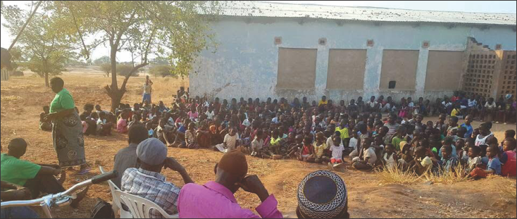

Chief Madothi's Children's School and Feeding Fund
A Fundraising Initiative by Chief Madothi, Robert Matewere & William
With the fundraising support of Mike & Adine who would prefer to be anonymous and would prefer to draw your attention to the real, incredibly worthwhile efforts of Mr. Robert Matewere, his nephew William and other community members.
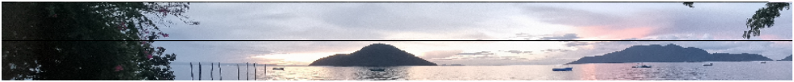
Chembe Village—nestled at Cape Maclear on the southern shores of Lake Malawi in the Mangochi District of Malawi—is a place where the lake sets the rhythm of daily life. Fishermen push out their wooden boats at first light, children walk to school along sandy paths, and evenings end with some of Africa’s most unforgettable sunsets over clear, island-dotted water. Cape Maclear was named in the 19th century (after astronomer Sir Thomas Maclear), and today Chembe remains a close-knit community whose livelihood depends on fishing, small-scale farming, and the growing trickle of eco-tourism.
This campaign supports local efforts to keep children in school and ensure they are well-nourished—simple interventions that make a lasting difference. Your contribution helps cover school fees and supplies, strengthens a community-run feeding program, and backs the people who quietly keep it all moving.
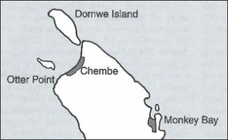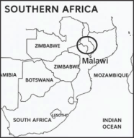
Please note: That this Fund is currently not a registered NPO with the Malawi Authorities, however we will be registered when funds are available to pay the MK 253,500 registration fee.

About the Fund and Its Administrators
While living in Cape Maclear, Mike and Adine were fortunate to meet Mr. Robert R Matewere, who is dedicated to ensuring local children receive an education, protection and support. Robert raises funds to cover school fees, uniforms, books, pens, pencils, and exam fees. He also ensures that the children attend school and that all funds are used appropriately. Robert serves as the official administrator of the fund, and his Malawi Identity Card is attached for verification.
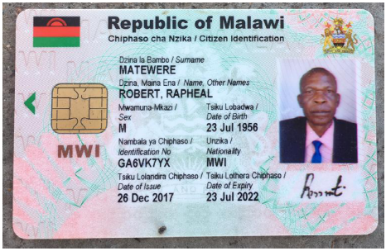
Working alongside him is his nephew, William, who has taken the initiative to run a children's feeding program. William, with the support of other community members, ensures that the funds raised go directly to feeding the children. His Malawi Identity Card is also attached for verification.
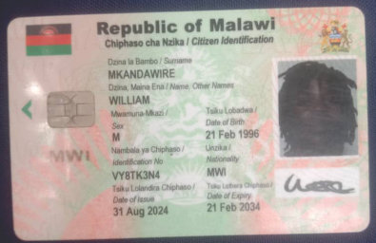
Mike and Adine were so impressed by Robert and William's dedication that they decided to help them raise funds to support their incredibly worthwhile efforts.
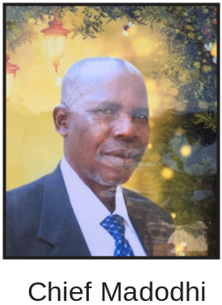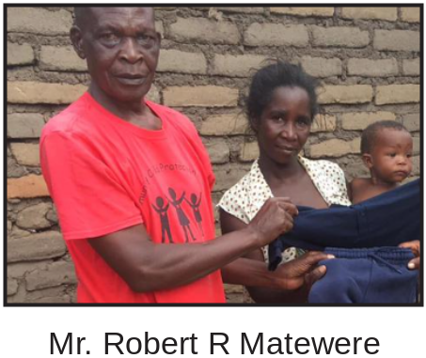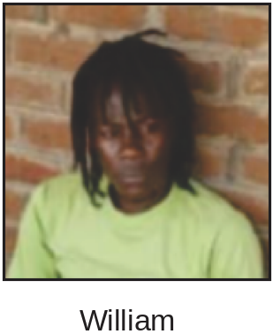

In essence, these are the costs involved in educating and feeding a child in the village.
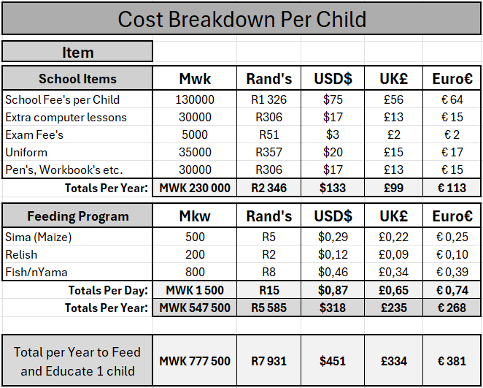

School Term Schedule
The school term schedule helps to ensure transparency and allows donors to see when fees and meals are required most.
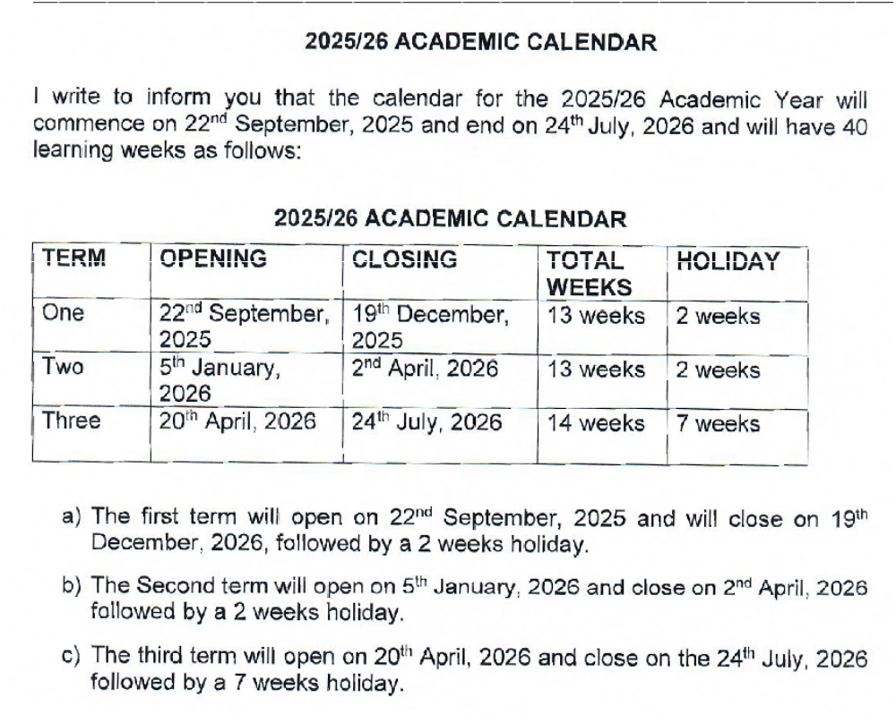

School Fees Support
Education is the key to opportunity. Funds raised are used to cover:
- School fees
- Uniforms
- Exercise books, pens, pencils
- Exam fees
Mr. Robert Matewere oversees the proper use of all funds.
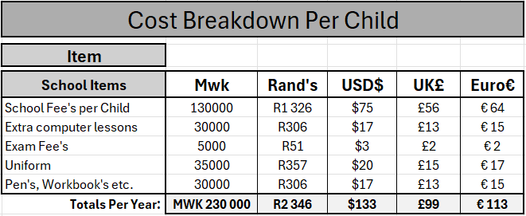

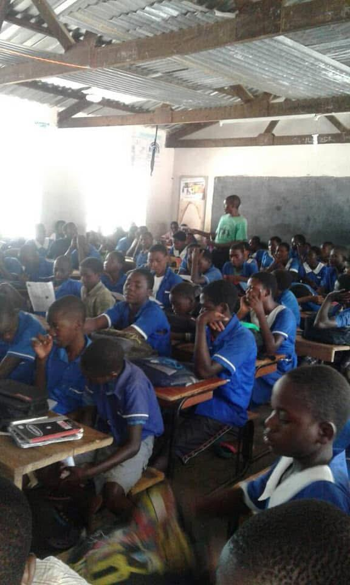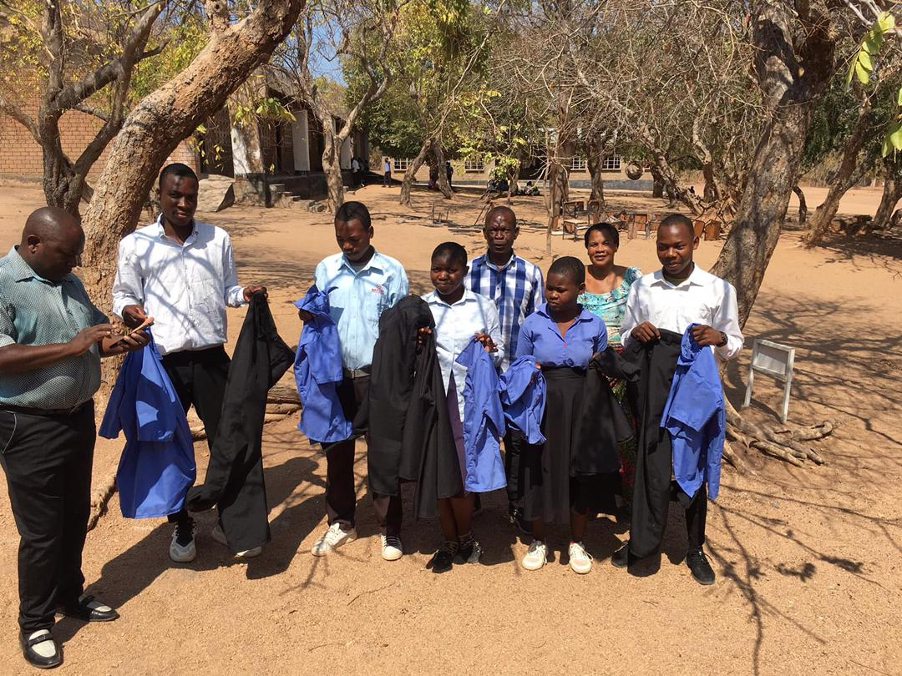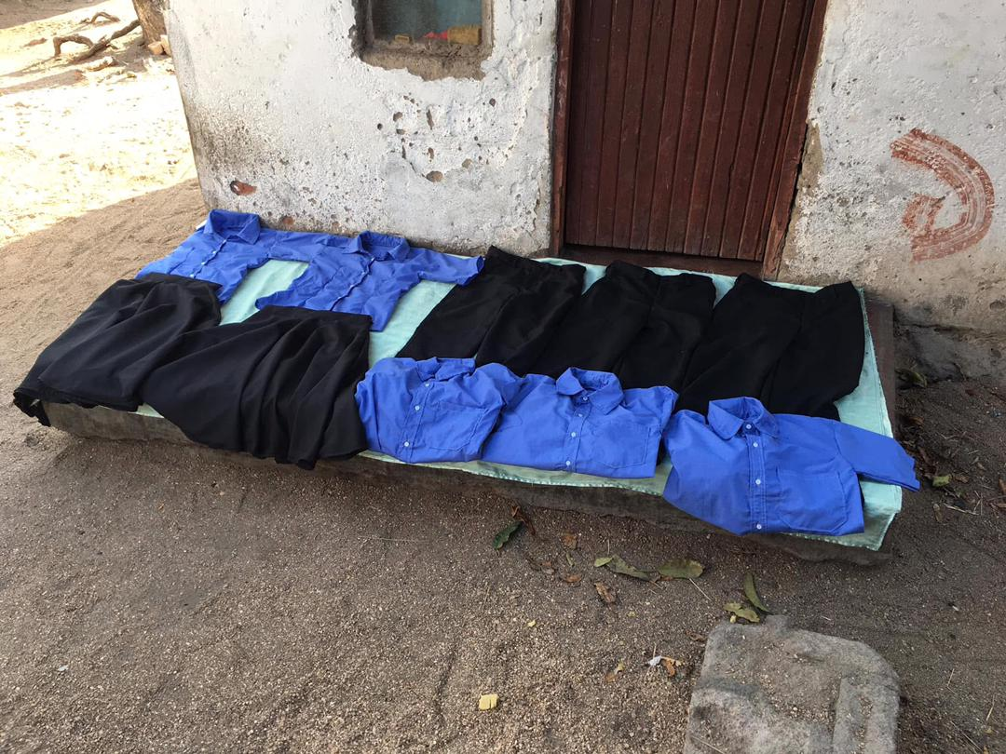

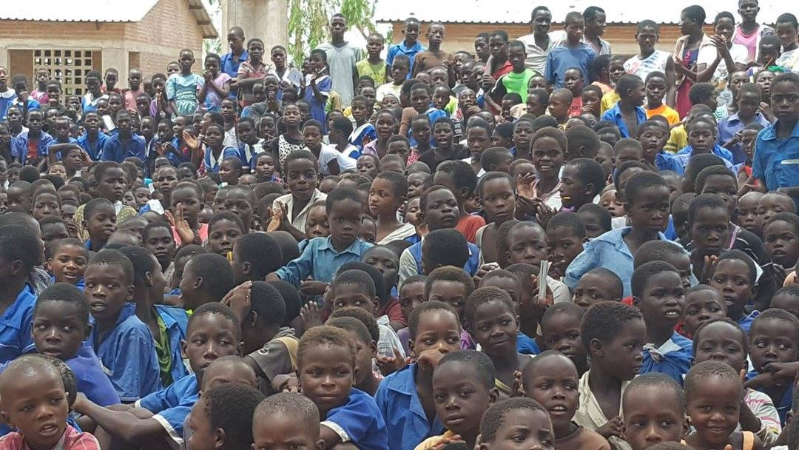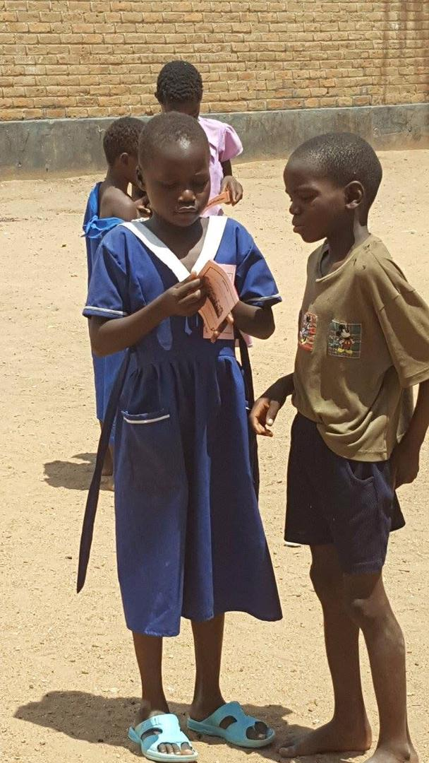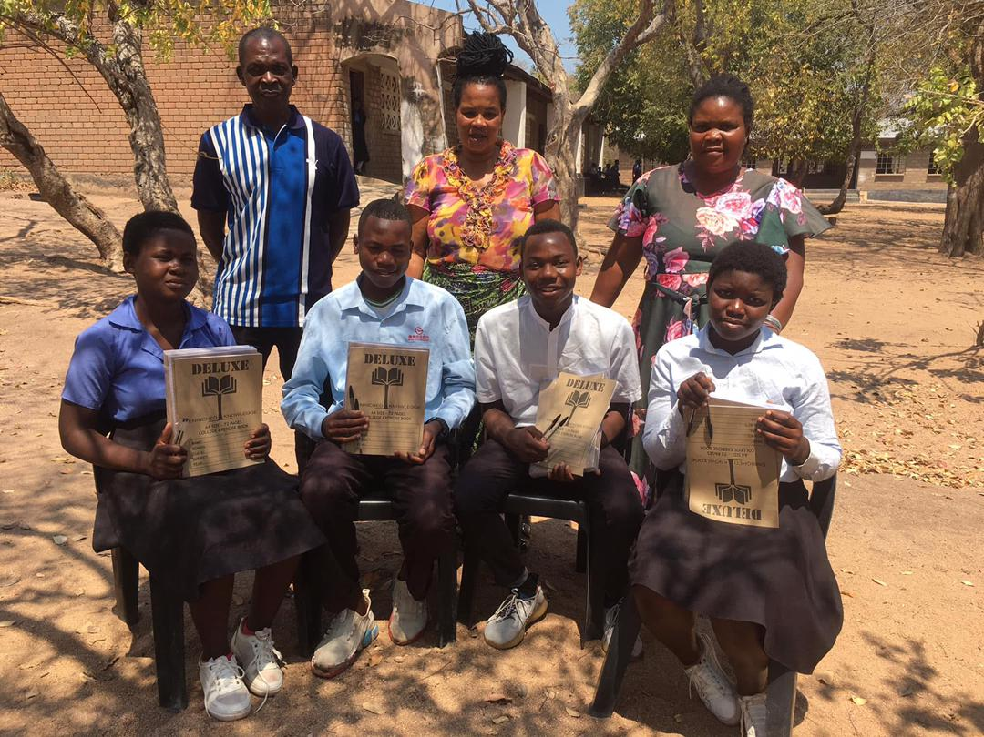

Feeding Program Initiative
No child should go hungry at school. William, Robert's nephew, together with the support of other community members, ensures that children are provided with nutritious meals during the school day, locally sourced from the village market.
This program helps children concentrate better in class and supports their health and wellbeing.
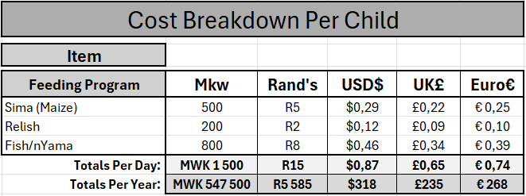
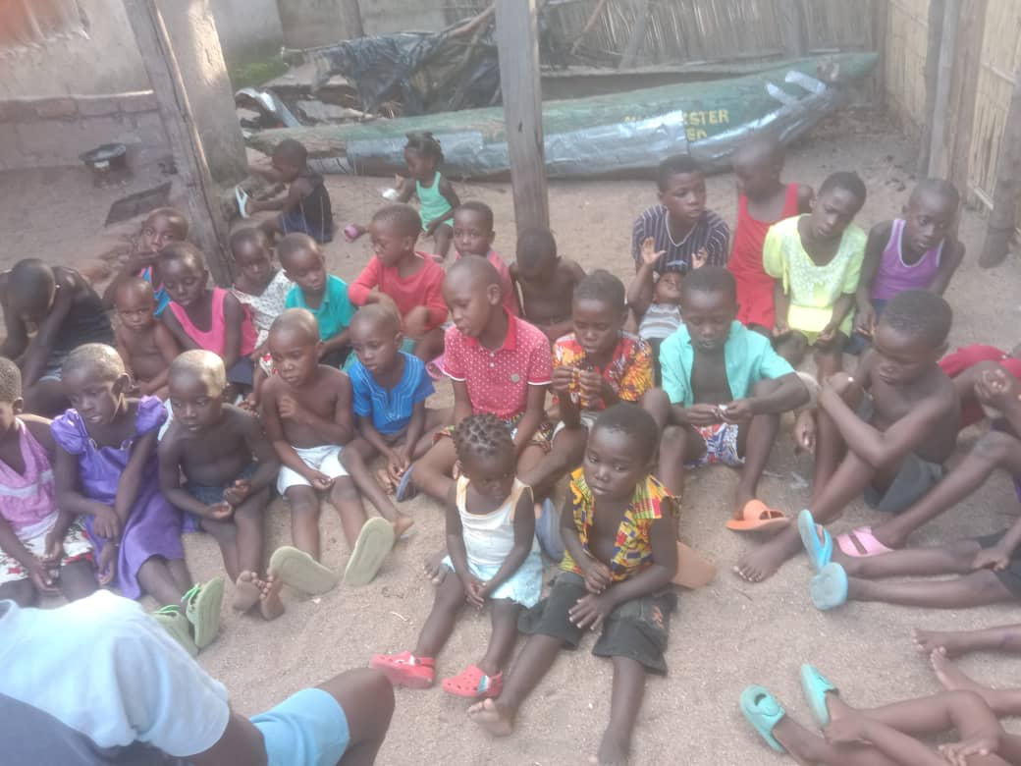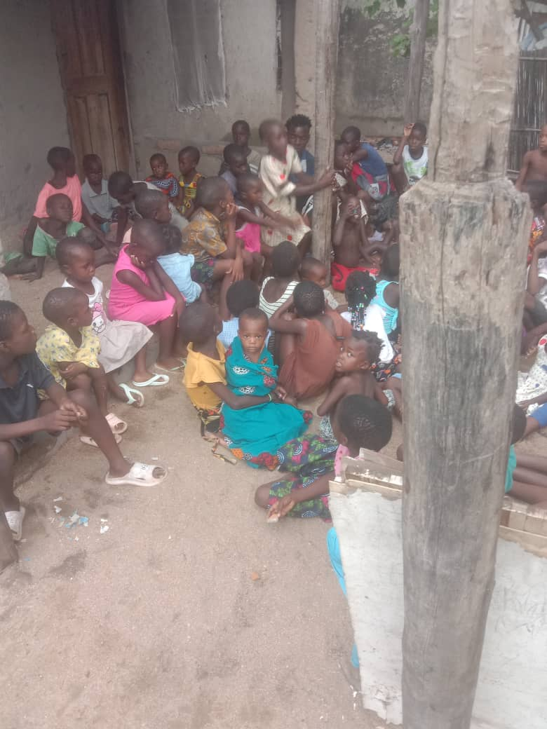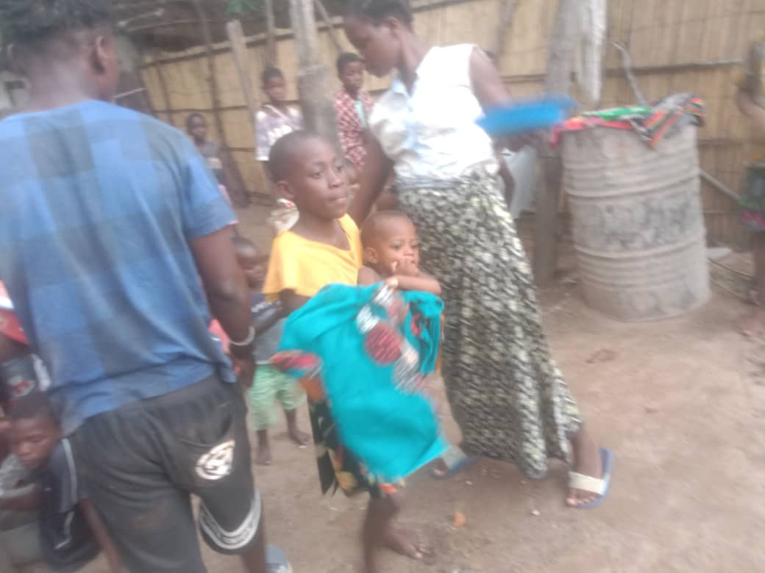

Additional Photos

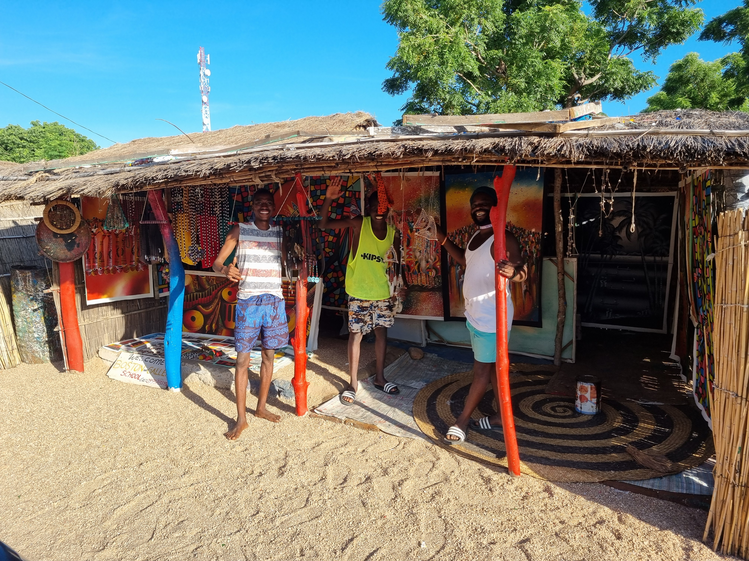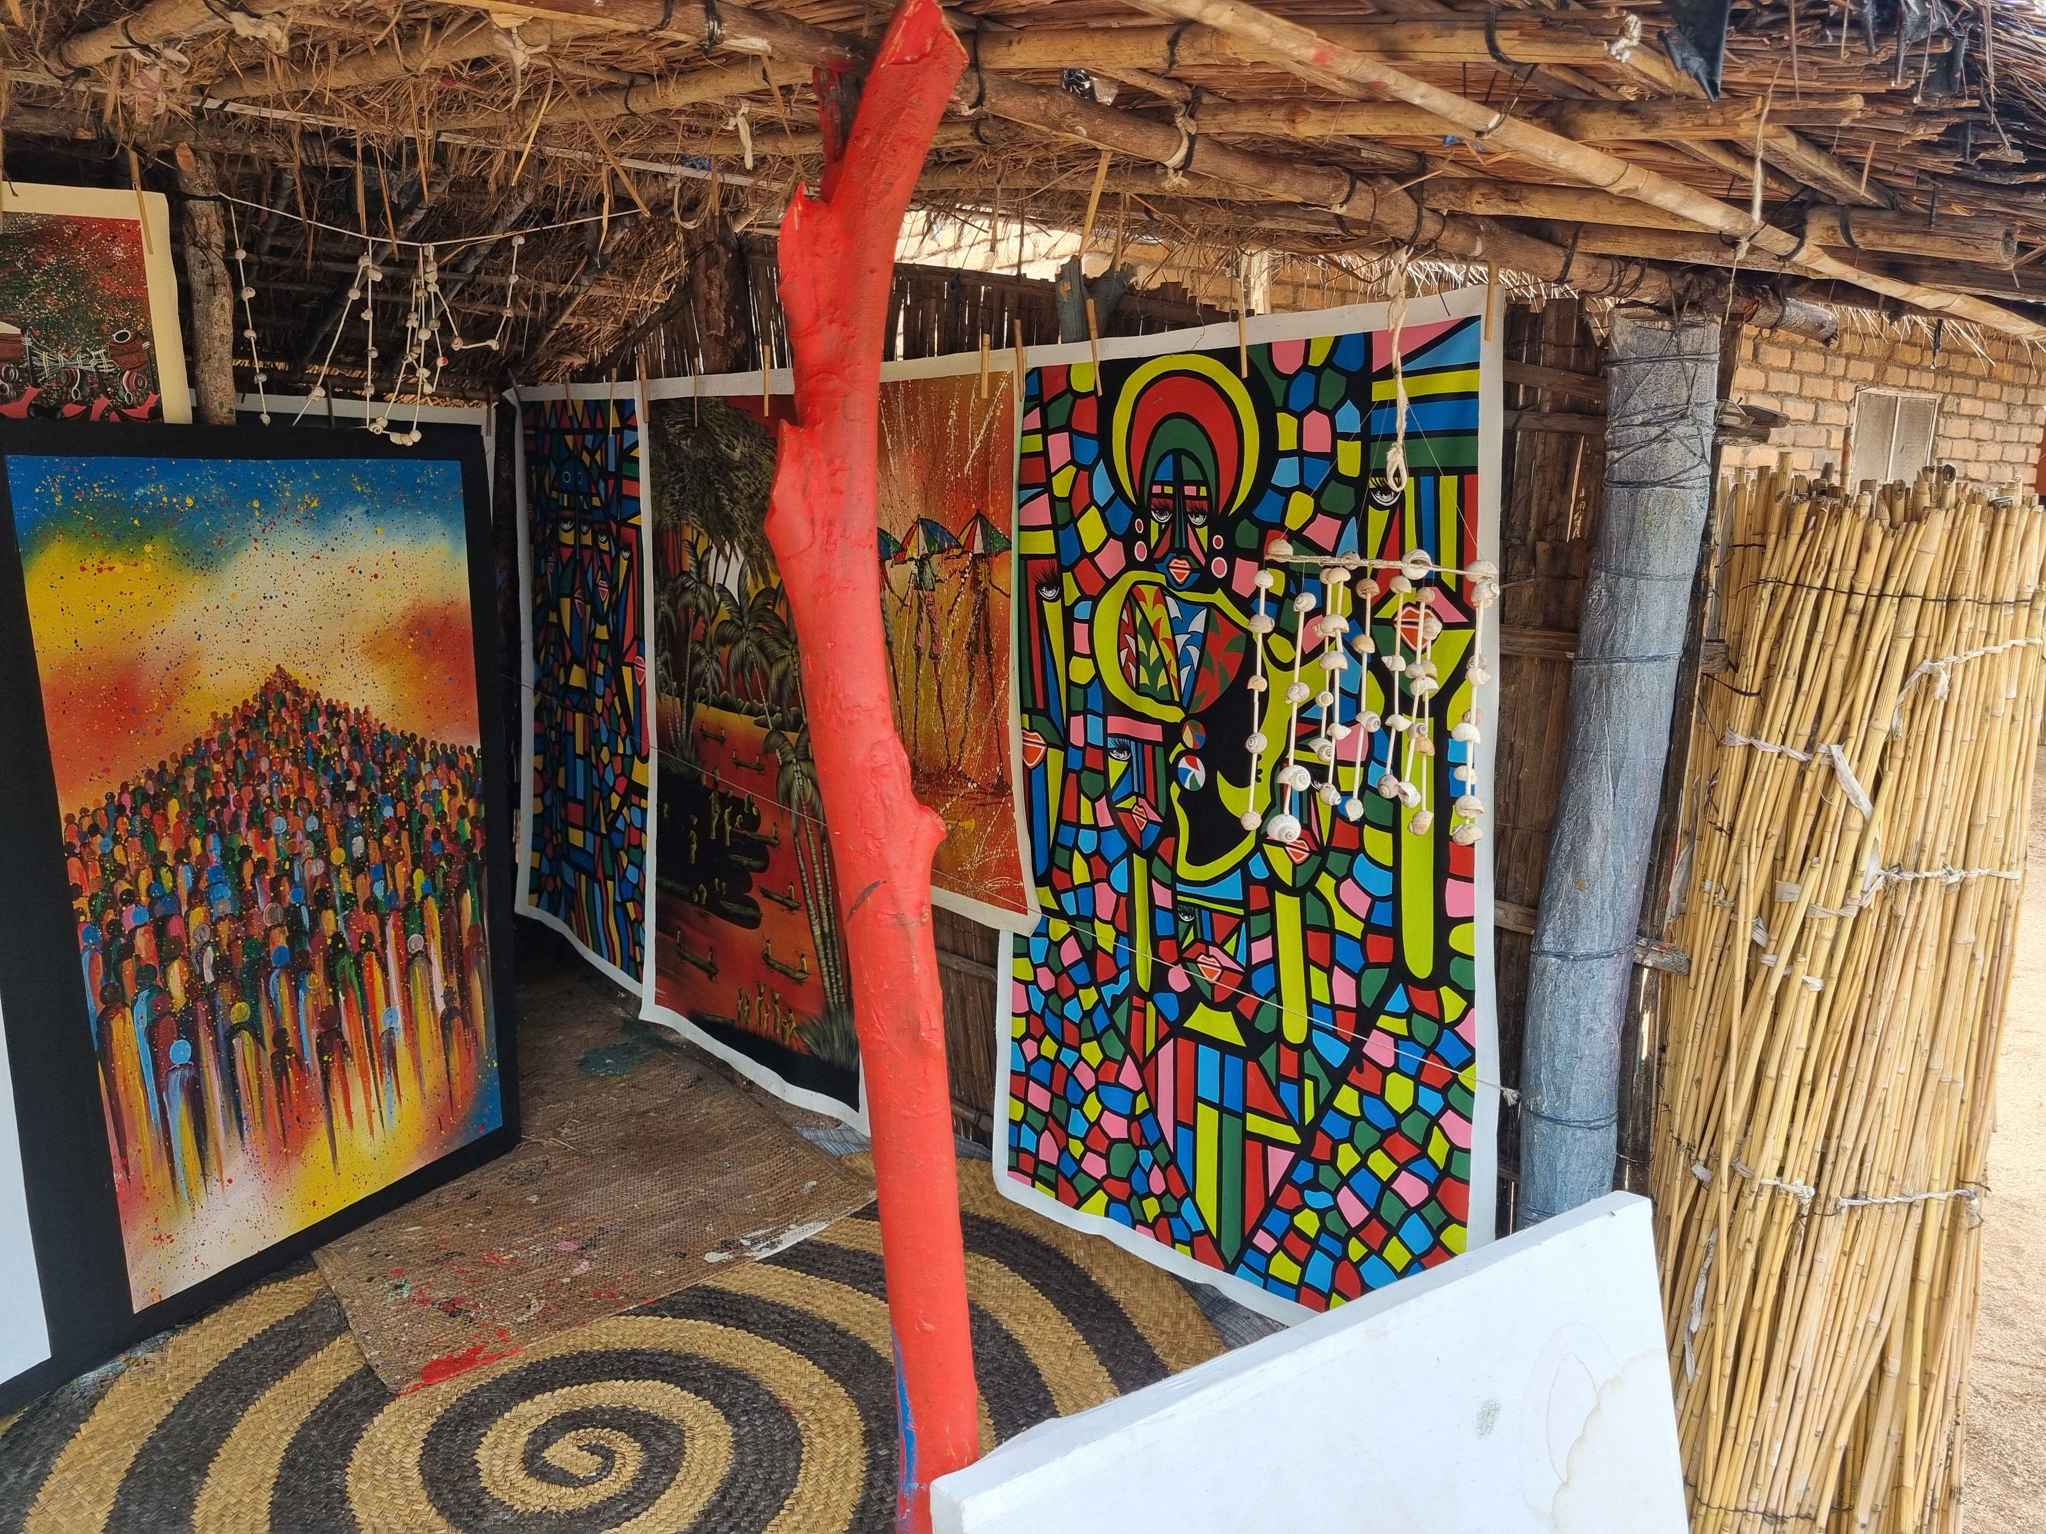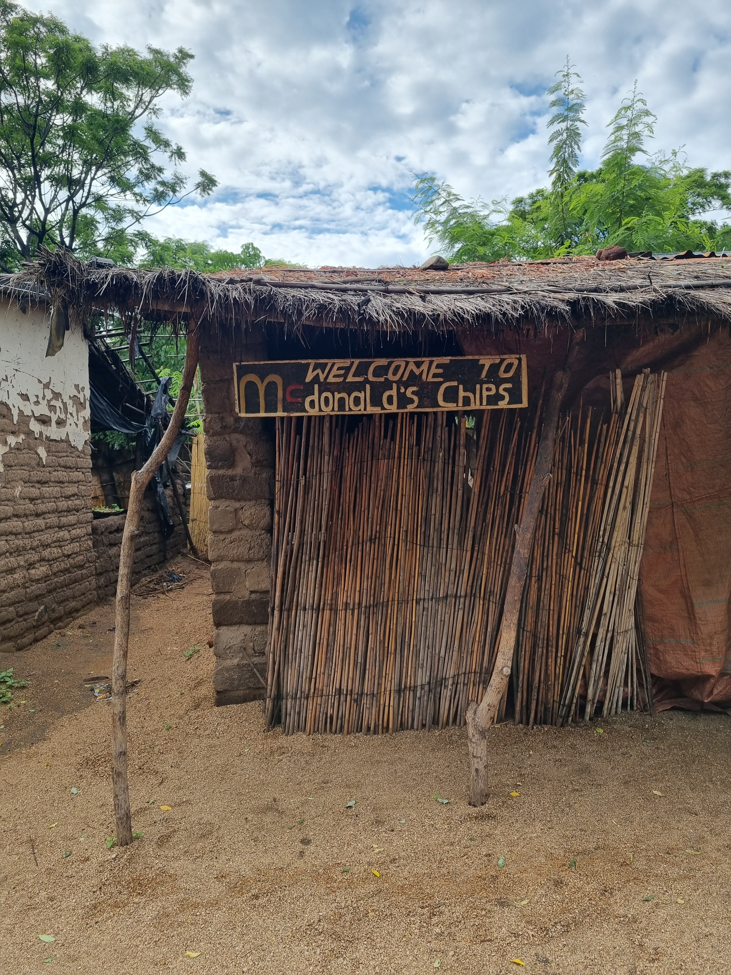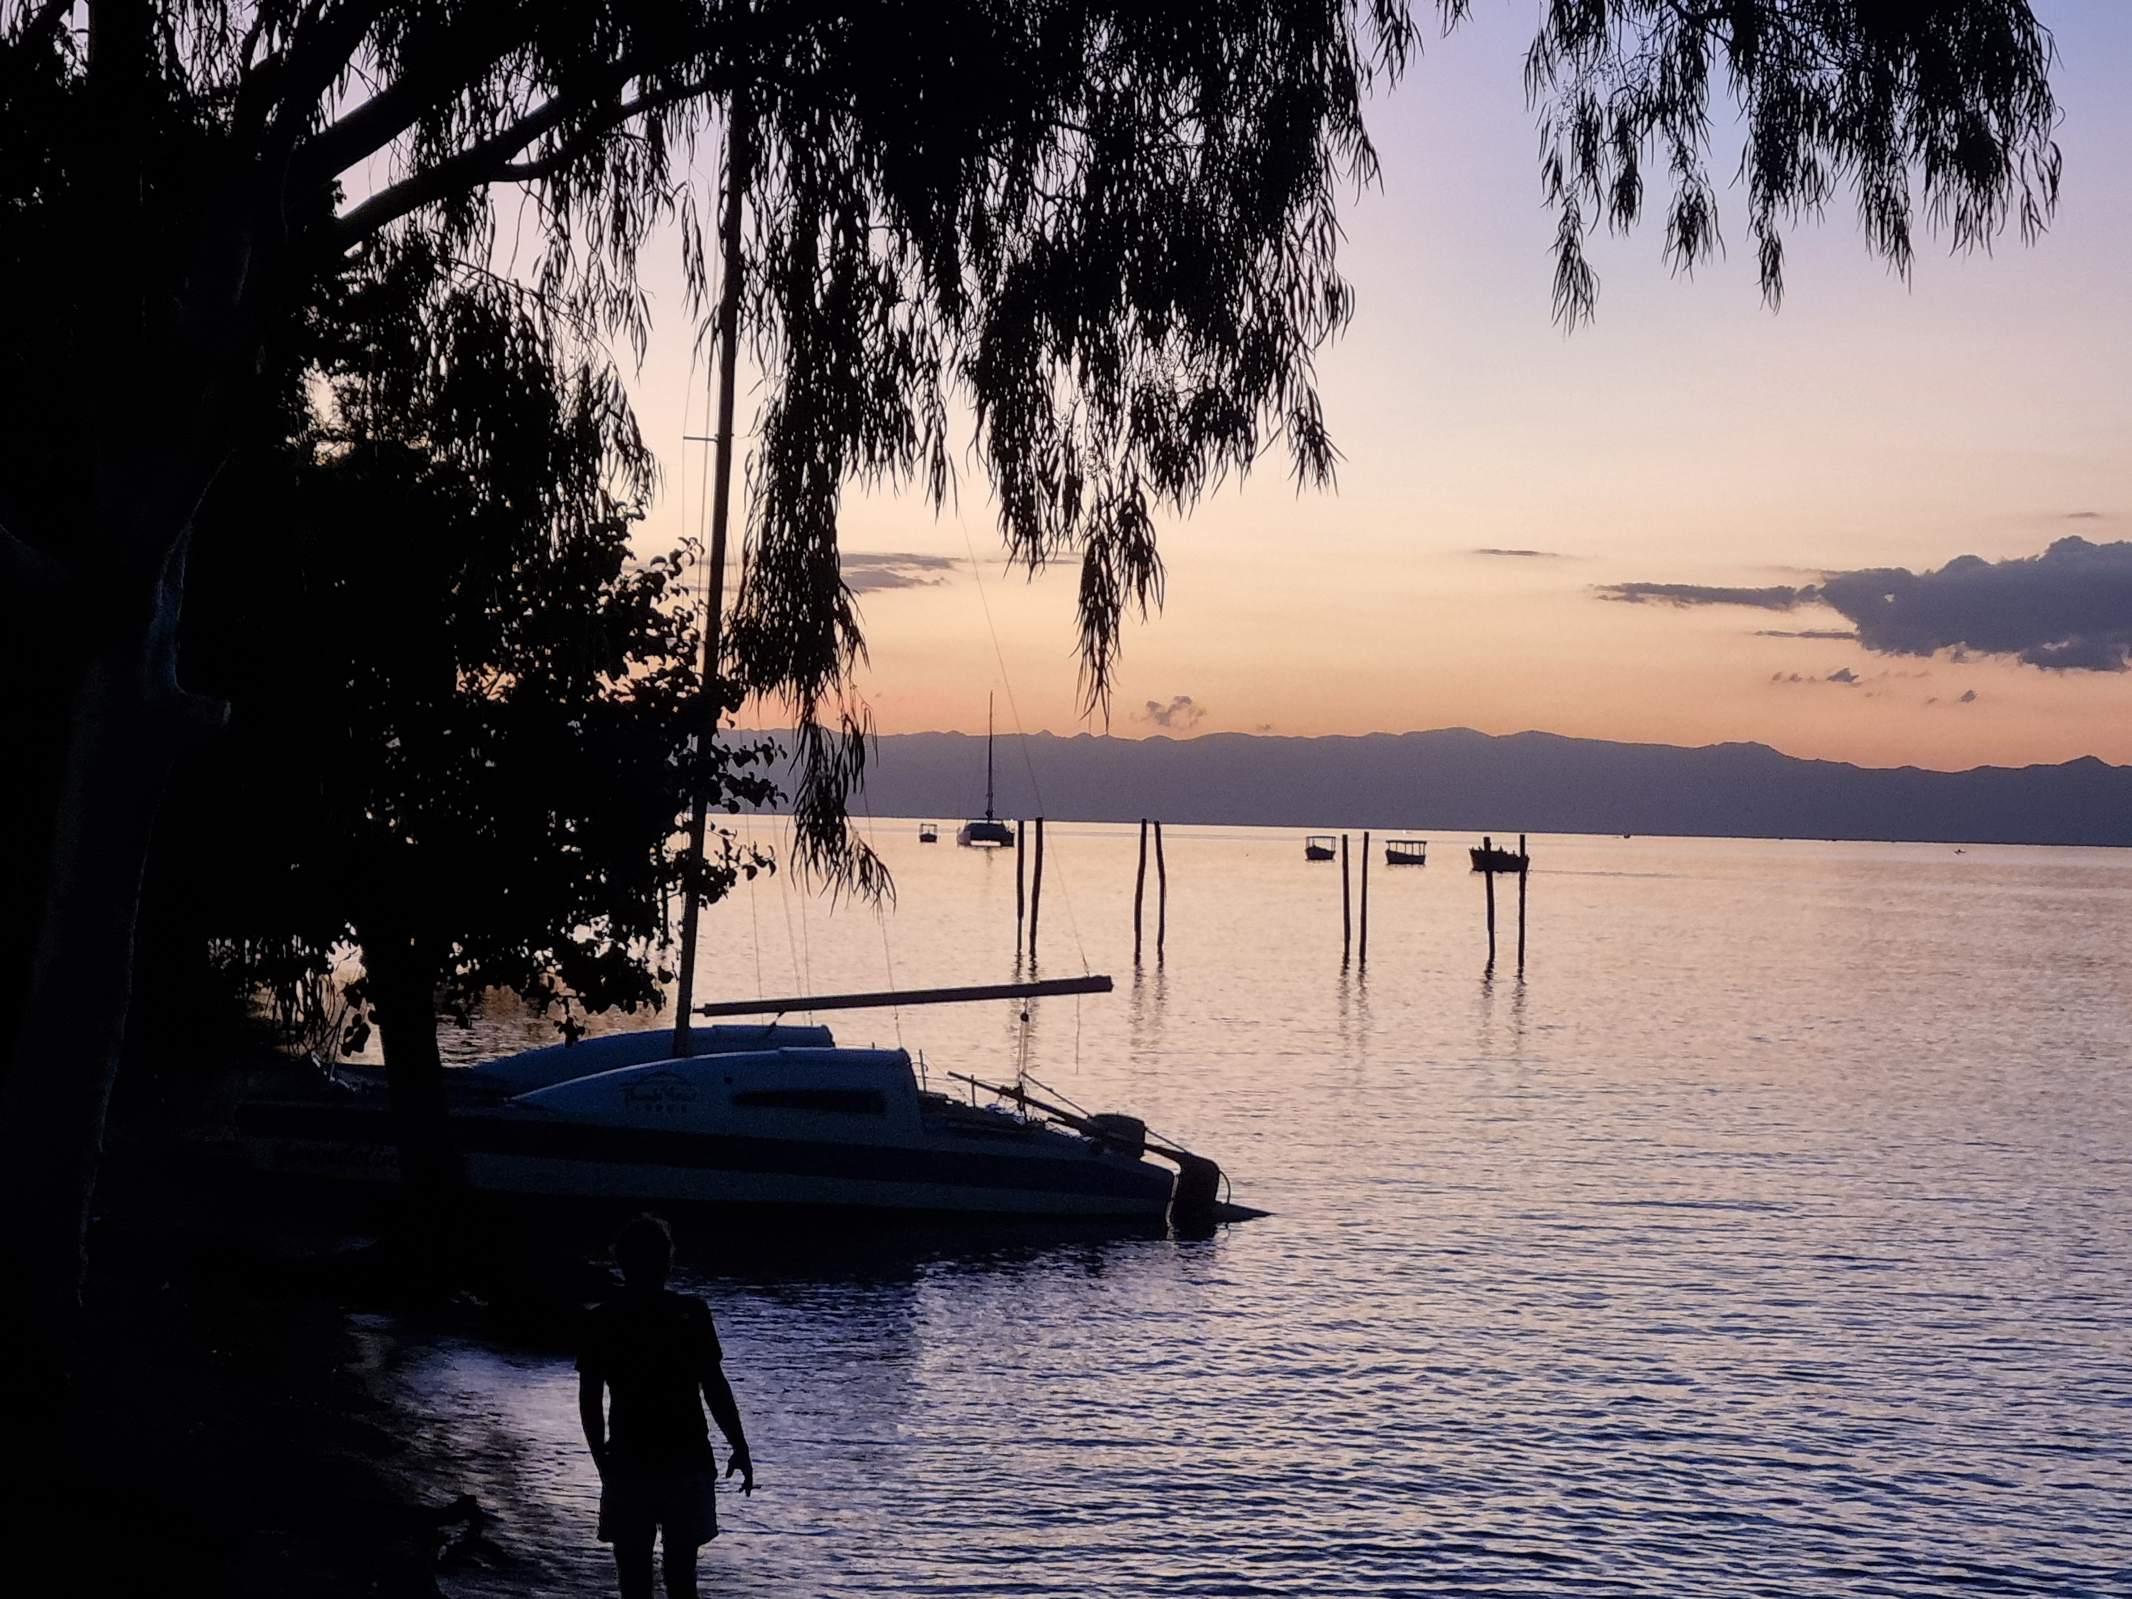

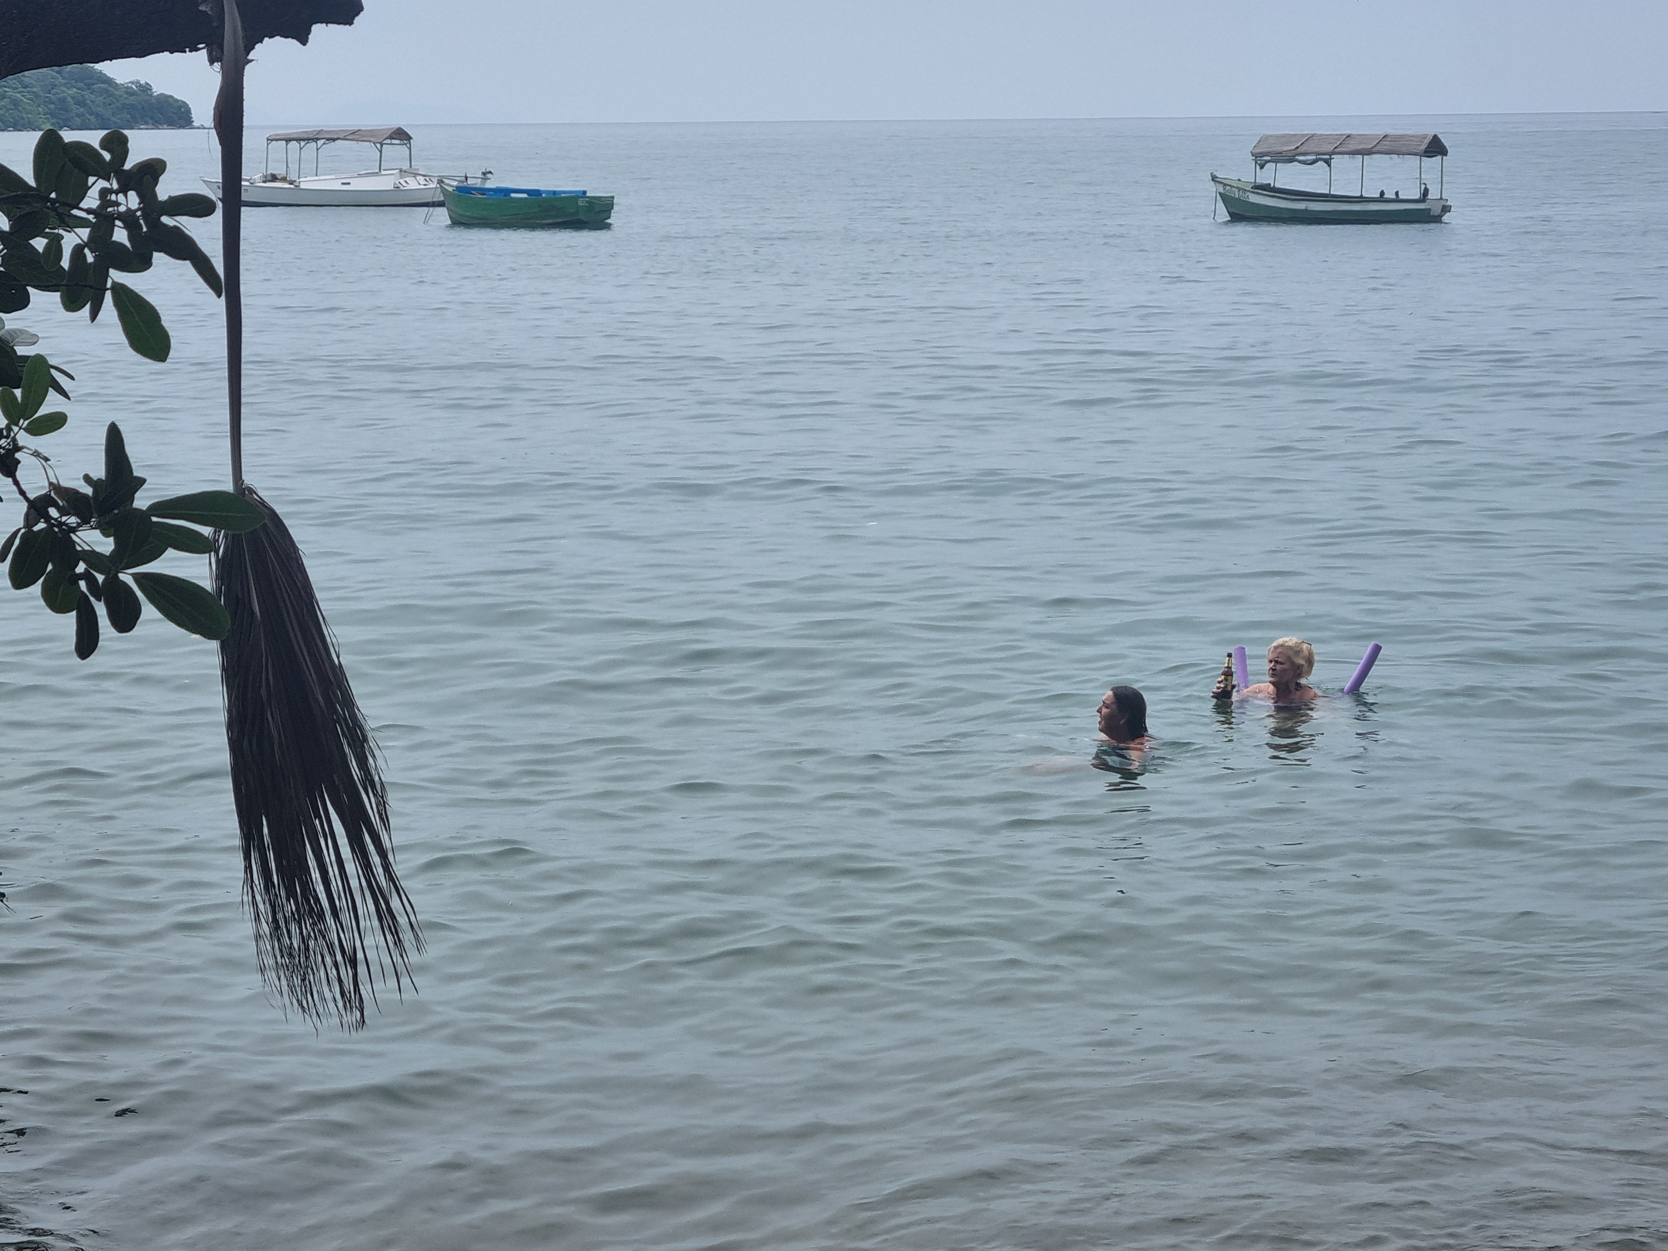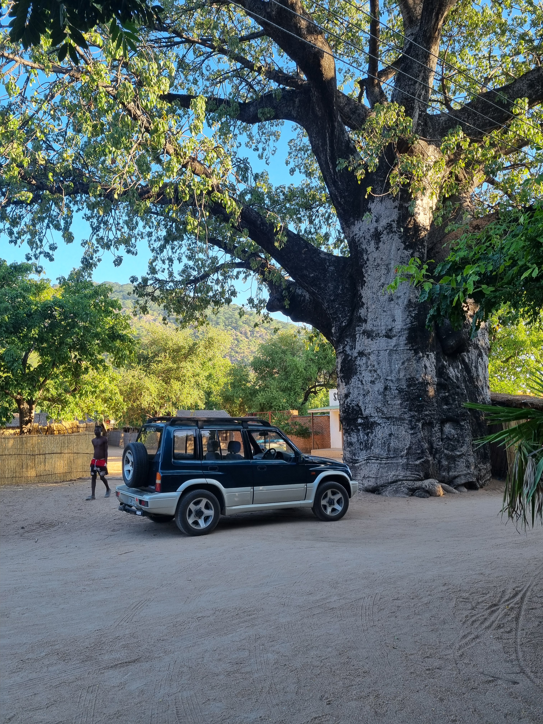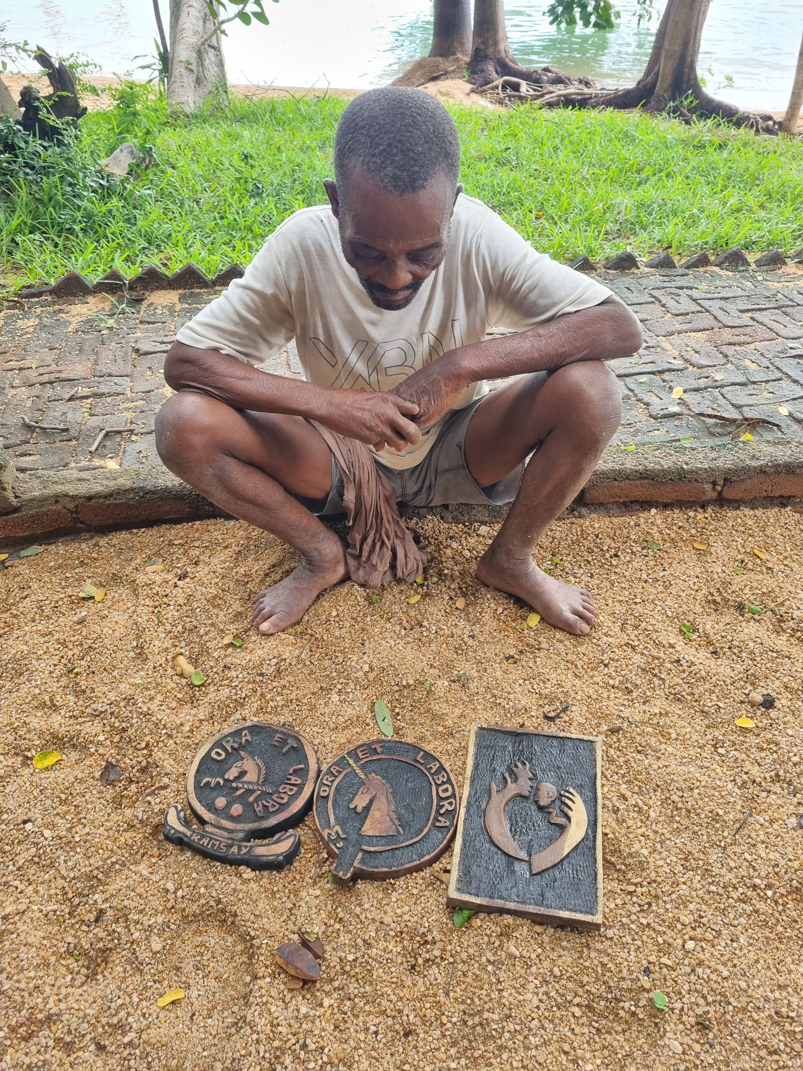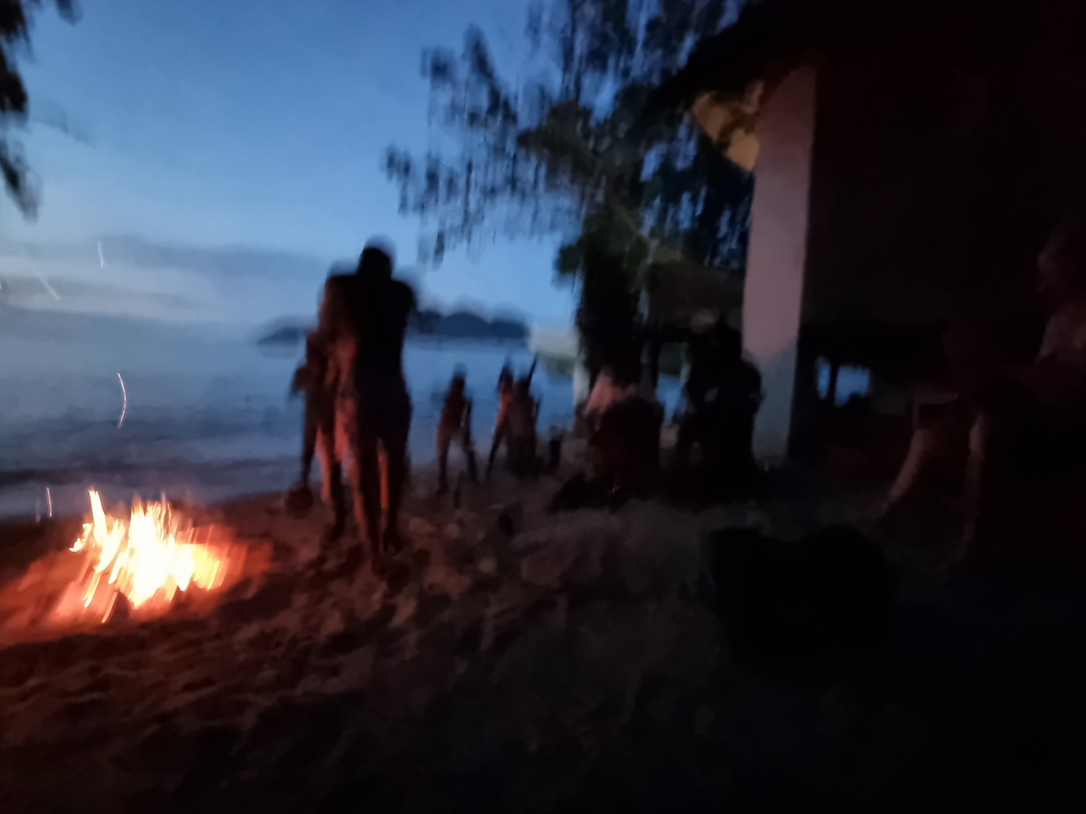

Thank You
We are deeply grateful to all supporters and donors who make this program possible.
Together, we can turn consistent support into consistent opportunity and ensure that the children in Cape Maclear have access to both education and nutrition—one set of school fees and one meal at a time.
Thank you so much for your support……
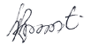
__________________________________
Mr. Robert R. Matewere, Chief Madothi, William, Mike and Adine

